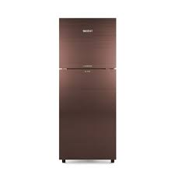

Dawlance 91996

* 135V Low Voltage Startup
* 35% Electricity Saving
* Color Maroon
* Thickest Insulation:
* **Rs.52,500**